
Sreenidhi Institute of Science and Technology
Ghatkesar, R.R District

Department of Computer Science & Engineering
Student Exit Survey

Name: Aman Kumar |  |  |  | Roll No: 22311A05R3 | Course: B.Tech |  | Branch: CSE |  | Section : E
Mobile No : 8858616679 | Mail –id: amankumar379312@gmail.com |  |  | % of Marks so far: 88% | Placed in Campus [Y / N] : Y If Yes specify Org. Name : ASSETSENSE
GRE Score : NA |  | TOEFL Score : NA | IELTS Score : NA |  |  | GATE SCORE :/Appearing NA |  | CAT Score : NA
Your Career Choice: JOB/Higher Education /MS/ Entrepreneur :
JOB

Rank - Guidance for feedback: Please give your opinion as stated below for all the items given here under.
Very Good : 5 | Good : 4 | Average : 3 | Satisfactory : 2 | Not So Satisfactory :1

Rate the level of Attainment of B.Tech C.S.E Programme Educational Objectives | Rank  [1-5]
I Graduates will have a strong foundation in fundamentals of mathematics, basic sciences,  computer science and engineering sciences with abilities to analyze problems, design and  development of optimal solutions to address societal problems. | 5
II Apply knowledge of diverse and emerging areas of computer science with modern tools to  solve the complex problems; also be sensitive towards health, safety legal, environmental  and sustainable issues to be professionally competent and globally employable. | 4
III Develop an ability to work effectively as an individual/team member or a leader or pursue  entrepreneurial skills with good communications and ethical ideologies, practice project and  finance management skills. | 4
IV Acquire research temperament to pursue higher studies in reputed national and  international institutes and become life-long learners. | 4

Rate the level of Attainment of B.Tech C.S.E Programme Outcomes(POs) | Rank  [1-5]
1. Engineering knowledge: Apply the knowledge of mathematics, science, engineering fundamentals, and an engineering specialization to the solution of complex engineering problems. | 4
2. Problem analysis: Identify, formulate, review research literature, and analyze complex engineering problems reaching substantiated conclusions using first principles of mathematics, natural sciences, and engineering sciences. | 4
3. Design/development of solutions: Design solutions for complex engineering problems and design system components or processes that meet the specified needs with appropriate consideration for the public health and safety, and the cultural, societal, and environmental considerations. | 5
4. Conduct investigations of complex problems: Use research-based knowledge and research methods including design of experiments, analysis and interpretation of data, and synthesis of the information to provide valid conclusions. | 4
5. Modern tool usage: Create, select, and apply appropriate techniques, resources, and modern engineering and IT tools including prediction and modeling to complex engineering activities with an understanding of the limitations. | 5
6. The engineer and society: Apply reasoning informed by the contextual knowledge to assess societal, health, safety, legal and cultural issues and the consequent responsibilities relevant to the professional engineering practice. | 4
7. Environment and sustainability: Understand the impact of the professional engineering solutions in societal and environmental contexts, and demonstrate the knowledge of, and need for sustainable development. | 5
8. Ethics: Apply ethical principles and commit to professional ethics and responsibilities and norms of the engineering practice. | 5
9. Individual and team work: Function effectively as an individual, and as a member or leader in diverse teams, and in multidisciplinary settings. | 5
10. Communication: Communicate effectively on complex engineering activities with the engineering community and with society at large, such as, being able to comprehend and write effective reports and design documentation, make effective presentations, and give and receive clear instructions. | 5
11. Project management and finance: Demonstrate knowledge and understanding of the engineering and management principles and apply these to one’s own work, as a member and leader in a team, to manage projects and in multidisciplinary environments. | 5
12. Life-long learning: Recognize the need for, and have the preparation and ability to engage in independent and life-long learning in the broadest context of technological change. | 4

Rate the level of Attainment of Program Specific Outcomes (PSOs) | Rank  [1-5]
- Apply the knowledge of computer architecture, software development life cycle, networking, database, web designing with emphasis on data structures and algorithms using programming languages and appropriate software tools to solve the specified needs of engineering problems. | 5
- Acquaintance of knowledge on the thrust areas such as Cloud Computing, Internet of Things (IoT), Data Science, Machine Learning, Network Security, Artificial Intelligence for solving societal and local problems with varying complexities. | 4
- Design and develop innovative prototypes or projects individually or in a team to solve the existing industrial problems using effective communication skills with due consideration to professional ethics, security, cultural and environmental contexts for sustainable professional development. | 4
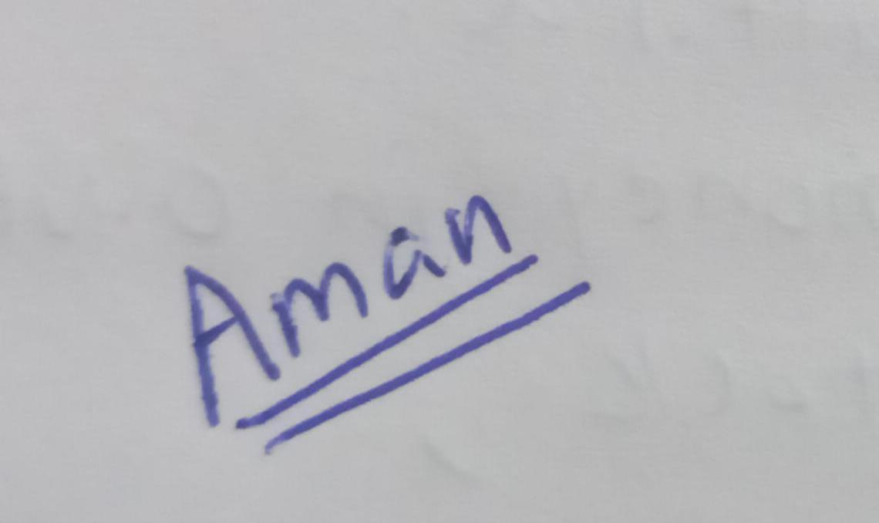

Signature

Rank - Guidance for feedback: Please give your opinion as stated below for all the items given here under.
Very Good : 5 | Good : 4 | Average : 3 | Satisfactory : 2 | Not So Satisfactory :1

 | Opinions on Curriculum | Rank  [1-5]
1 | Pl. rate the overall quality of the curriculum with respect to basic sciences, humanities Professional Core and interdisciplinary courses? | 4
2 | Pl. rate the employability Courses and Core courses [Theory and labs.] have adequately prepared you for employment and higher studies? | 3
3 | Pl. rate the open and professional elective courses. | 4
4 | The extent of conduct of Seminars, Workshops and Student Development Programmes has enabled you to improve oral, written communication and technical skills. | 5
5 | The extent of use of IT Technologies, modern software tools to design and develop the application were adequate? | 4
6 | The extent of attainment of technical abilities through group, mini and main projects to face the challenges of taking up new projects in your professional career ? | 5
7 | Extent of coverage of environment, economics studies and management were covered in the programme ? | 5
8 | Extent of coverage of Human Values , Ethics, IPR and Sustainable Development were addressed? | 5
9 | The extent of opportunities given to you to perform as team member / team leader to achieve common goal?[group, mini , major project, co-curricular and extra-curricular activities] | 5

 | Opinions on Department and Faculty members  [Pl. give Overall Opinion] | Rank  [1-5]
1 | Pl. rate the Teaching Quality, use of Teaching Aids, Quality of Lecture Notes and Conduct of Laboratory experiments . | 4
2 | Pl. rate the contribution of your faculty in Employability Enhancement , Personality Development and Overall guidance . | 4
3 | Pl. rate the extent of help you received through Course Files and Lab. Manuals etc. | 5
4 | Rate your opinion on Group, Mini and Major Projects. | 5
5 | Rate the Problem Solving Activity in the class room. | 5
6 | Rate the fairness in the methodology of Evaluation process. | 5
7 | Pl. rate the conduct of Workshops, Guest Lecturers, Professional Activities, Co-Curricular and Extra – Curricular activities . | 4
8 | The extent of Scope provided for self learning [assignments, group project, technical seminars ] | 5
9 | Pl. rate the extent of your exposure to Entrepreneurship and Innovations | 4

 | Opinions on Infrastructure and Institutional Management |  | Rank  [1-5]
1 | Pl. rate the facilities provided in the class rooms [ LCDs’ , OHPs’, Lighting etc..] |  | 4
2 | Rate the functioning of the Laboratory Equipment [Facility for conduct of experiment ] |  | 4
3 | Rate the services provided by the library[ book bank schemes etc |  | 5
4 | Rate the Computing Services at SNIST ?[Software facilities, Internet , WiFi , Xerox facility , Printing facility ] |  | 5
5 | Pl. rate the encouragement given by the Executive Director / Principal and others in the Co-Curricular activities under the banner of IEEE, ISTE, IETE etc. |  | 5
6 | The extent of facilities provided to you for Sports and Games at SNIST . |  | 4
7 | Rate the encouragement given for Extra-Curricular Activities for Personality Development Activities under ARTS CLUB, SPARDA etc. |  | 5
8 | Rate the encouragement given engaging in Service given to Society. [ Bachpan Bachao, Street Cause, NSS etc.] |  | 5
9 | Rate the quality of Hostel facilities available ?[pl. answer if you are using this]
10 | Rate the Canteen facilities available at SNIST. [pl. answer if you are using this] |  | 3
11 | Rate the administration services provided by the college. [Physical Education , Transport , Accounts etc.] |  | 4
Opinions on Employability Enhancement efforts of College
1 | Pl. rate provision of employability enhancement activity through curriculum itself [ LR, QA, Soft skills] |  | 5
2 | Rate the provision of employability enhancement activity through External Experts [ CRT etc.] |  | 5
3 | Rate the study/practice material given to you for Employability Enhancement |  | 4
4 | Rate the Career Guidance received through faculty and External Trainers |  | 5
5 | Rate the Placement services , Placement Intimation / Off Campus Placement etc. |  | 4
Suggestions for Improvement
1 | Department Assessment
 | a. What are the 2 major strengths of your department?
 | i. | HOD, Faculty
 | ii. | Department is known for conducting technical workshops, guest lectures and promoting hackathons.
 | b. What are the 2 major weaknesses of your department?
 | i. | Lack of appropriate format for documentation and exploring new technologies
 | ii. | More encouragement can be given to the students to explore the job opportunities and entrepreneurship.
2 | What are your suggestions for further improvement in the quality of your Programme ?  I suggest to introduce the courses that are relevant to the current job market and have lot of future scope to it and make students gain practical knowledge along with theory knowledge.
3 | What are your suggestions for improvising the curriculum ?  - Any new courses should be offered? [please specify]  Applied Data Engineering, Quantum Computing and its applications, Cyber Security and Ethical Hacking, AIML for edge computing and IOT  - Any existing courses to be dropped? [please specify]  WMP, physics, chemistry, and entrepreneurial subjects can be checked once again to avoid redundancy.  - Any course to be moved from one semester to another semester?  Subjects that have more weightage in placements should be covered by 3-1 making students to be ready for the placements.  - Any modifications in the syllabus of any course? [If so, please specify the name of the course and the topics]  Yes, web technologies course can be improvised to meet the software standards in the current market, and practical applications scope to be provided for AIML, cloud native courses.
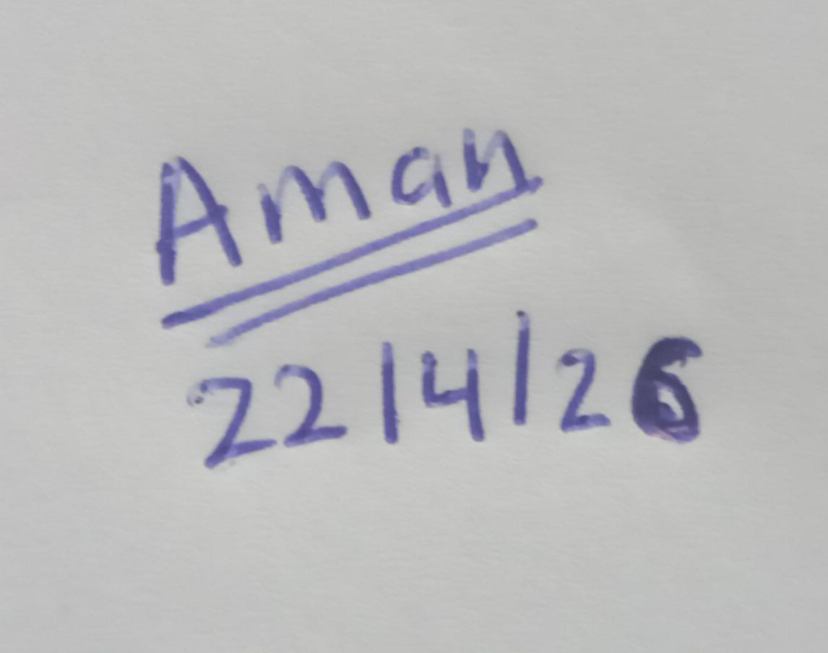

Signature of the student Signature of the Coordinator
(with date)

